Kieffer P. Santos Assignment 1

AMAT 163

An example I found is from a journal article “Student learning time analysis during COVID-19 using linear programming - Simplex method” by Pardeshi et al.

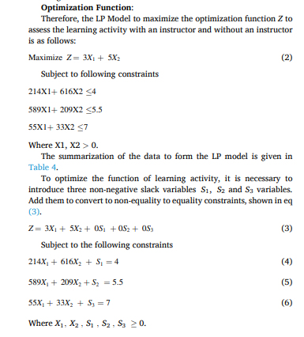

Figure 1. Screenshot of the Optimization model from the journal article of Pardeshi et al.

From the figure above, we can see that the model is continuous since there are decimal numbers on the constraints. Also, the optimization model is constrained since we can see constraints. We can also see that it is single-objective since there is only one objective function. Furthermore, since the constraints, on the left side of the inequalities are number of students, it is dynamic.

Additionally, the type of the optimization model, as mentioned also in the journal article, is an LP model.

The objective function in their model is to



And the constraints are

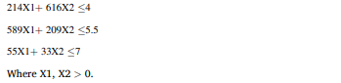

Where the domain is all real numbers.

The optimal solution found on the article is that $X_{1}=0.009332341$ and $X_{2}=0.006432907$ with $Z=0.06016155$.

**References**

Pardeshi (Assistant Professor), S., Gawade (PhD, Professor), S., & Hemant (PhD, Senior Research), P. (2022, March 15). *Student learning time analysis during COVID-19 using linear programming - simplex method*. Social Sciences & Humanities Open. https://www.sciencedirect.com/science/article/pii/S2590291122000201